Name : Lokare Mahir Abdul Majeed

Roll no : 23AI34

Batch:02

Experiment No: 08

AIM: To study and implementation of Principal Component Analysis(PCA).

RESOURCE REQUIRED:

Google repository, Dataset, Jupyter Notebook

THEORY:

PCA (Principal Component Analysis) is a dimensionality reduction technique and helps us to reduce the number of features in a dataset while keeping the most important information. It changes complex datasets by transforming correlated features into a smaller set of uncorrelated components.
It helps us to remove redundancy, improve computational efficiency and make data easier to visualize and analyze.
Working of Principal Component Analysis
PCA uses linear algebra to transform data into new features called principal components. It finds these by calculating eigenvectors (directions) and eigenvalues (importance) from the covariance matrix. PCA selects the top components with the highest eigenvalues and projects the data onto them simplify the dataset.
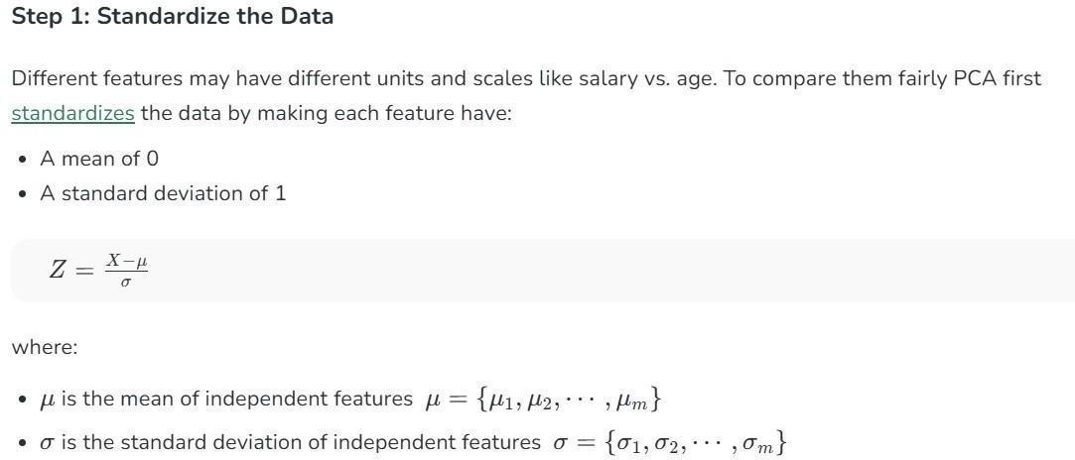

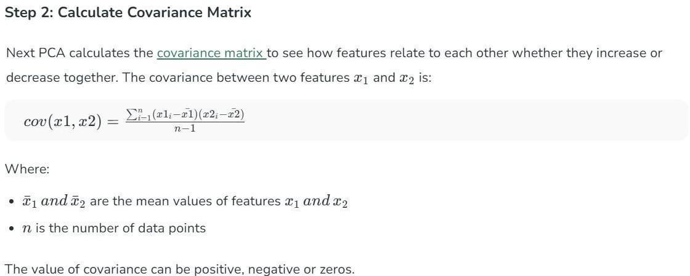

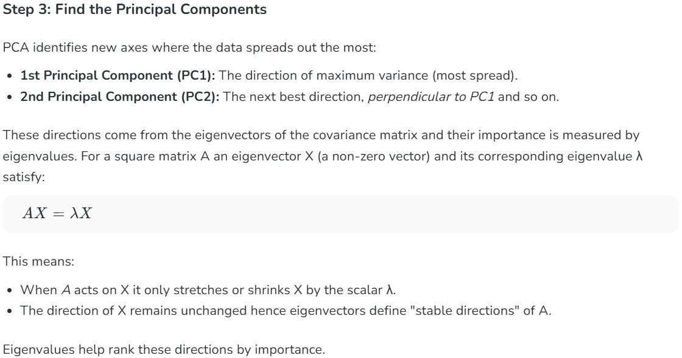



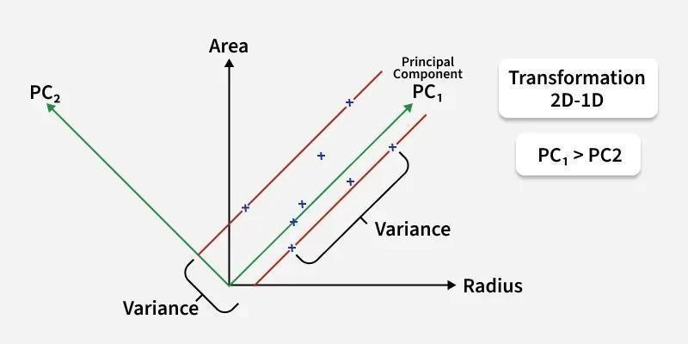

In the above image the original dataset has two features "Radius" and "Area" represented by the black axes. PCA identifies two new directions: PC₁ and PC₂ which are the principal components.
- These new axes are rotated versions of the original ones. PC₁ captures the maximum variance in the data meaning it holds the most information while PC₂ captures the remaining variance and is perpendicular to PC₁.
- The spread of data is much wider along PC₁ than along PC₂. This is why PC₁ is chosen for dimensionality reduction. By projecting the data points (blue crosses) onto PC₁ we effectively transform the 2D data into 1D and retain most of the important structure and patterns.

IMPLEMENTATION:
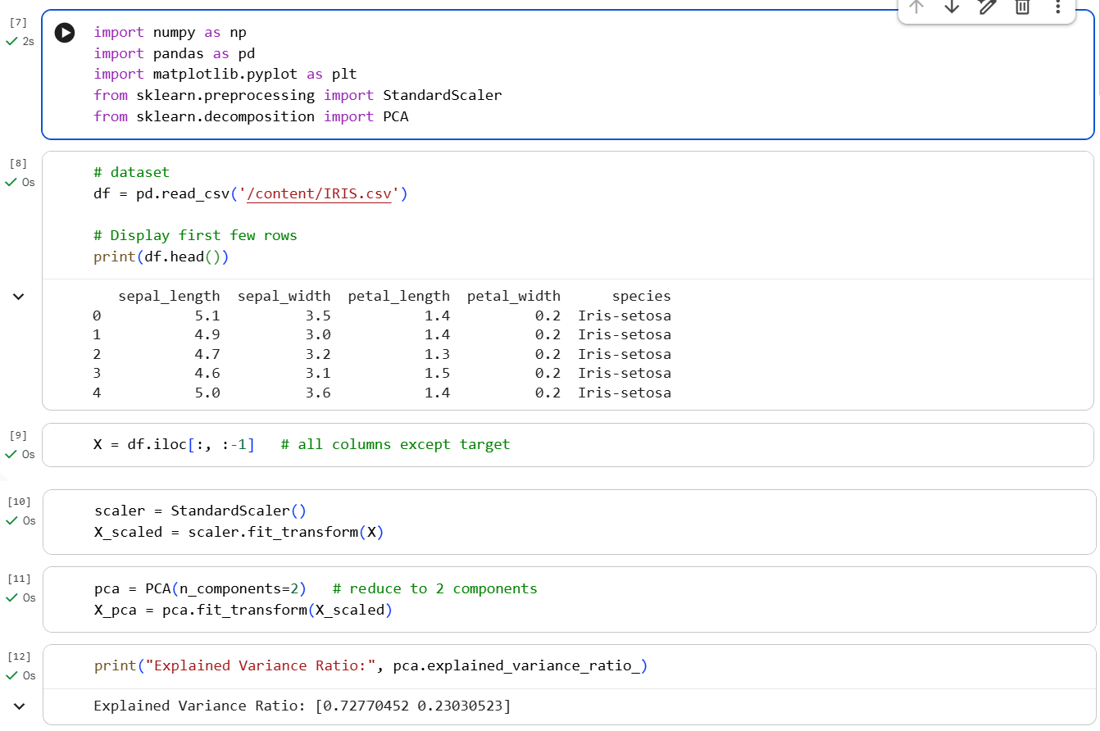

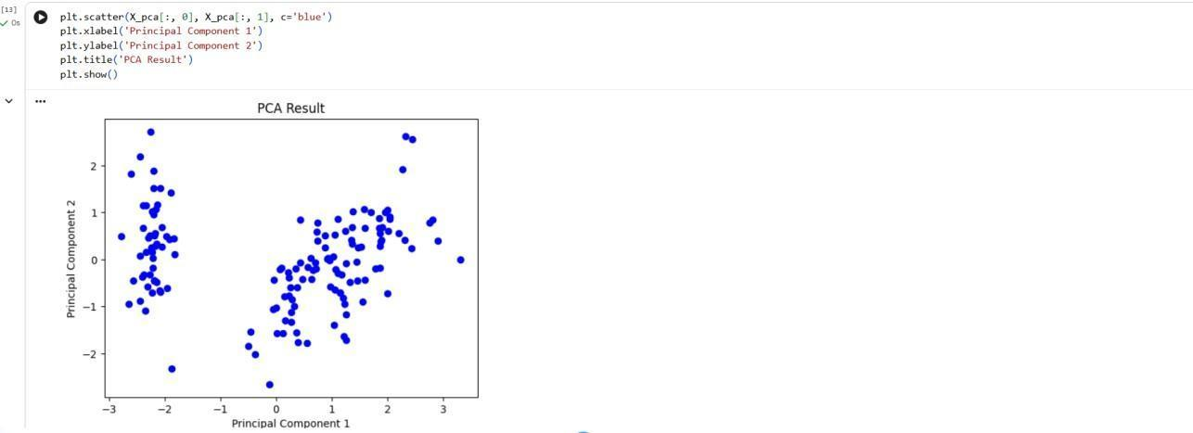

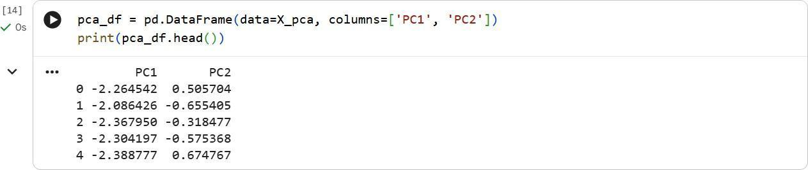

CONCLUSION:

Hence we have studied and implemented Principal Component Analysis (PCA) the unsupervised dimensionality reduction technique in machine learning which is used to transform high-dimensional data into a lower-dimensional representation.

